Company Level Options
Pay for applications under the tab “My Pending Fee” from the menu option “Dashboard”:

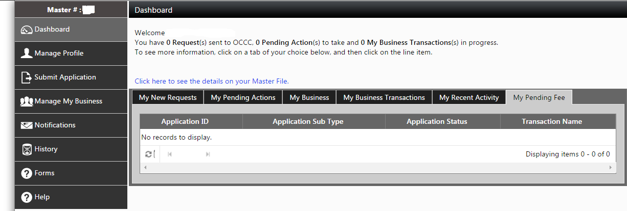
Provide termination notices for licensed employees after clicking on “Inactivate Pawn Employees” under the menu option “Manage My Business”:
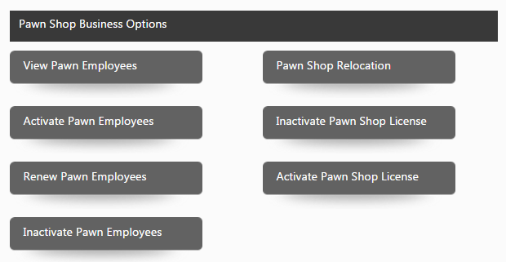
View all employees licensed at company after clicking “View Pawn Employees” under the menu option “Manage My Business”
Export to excel a list of employee names, license numbers, and license dates from the “View Pawn Employees” option.

