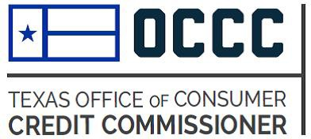
OCCC Debt Cancellation Agreement Submission Form
Your First Name: Your Last Name:

Your Company’s Name (include full name and any d/b/a):

Your Address: | Your Phone/Fax Number(s): Phone:  Fax:
Your Email Address: | Date Form Is Being Submitted: (mm/dd/yyyy)
Form Number (should uniquely identify the form submitted): | Date Form Was Last Revised: (mm/dd/yyyy)
- Required Nonrefundable Filing Fee: $250 for each submitted debt cancellation agreement

- Submission Process: Before submitting the agreement, we encourage you to read the OCCC's advisory bulletin, "Review of Debt Cancellation Agreements Requiring Insurance” posted on our website.

The submission process involves two steps. First, e-mail a completed copy of this Submission Form and a scanned Abode Acrobat (pdf) “clean” version of document to DebtCancellationForms@occc.texas.gov. Second, mail the check for the $250 nonrefundable filing fee, a copy of this Submission Form, and, if desired, a copy of the debt cancellation agreement to:
Office of Consumer Credit Commissioner 2601 N. Lamar Blvd.
Austin, TX 78705
The submission is not considered complete until the nonrefundable filing fee and debt cancellation agreement is received by our agency.
C: Certificate of Compliance: Before sending the agreement to the OCCC, carefully review the agreement and check all boxes to acknowledge the following:
The agreement is a debt cancellation agreement that is intended to be used for motor vehicle retail installment transactions under Chapter 348 of the Texas Finance Code.
The agreement includes insurance coverage as part of the buyer's responsibility to the holder.
The agreement includes all provisions required by Section 348.603 of the Texas Finance Code.
The agreement does not contain any inconsistent or misleading provisions.
Any exclusions in the agreement are fully disclosed in plain language.
Approved debt cancellation agreements are public information under Section 348.604(f) of the Texas Finance Code.
Signature: Your Name:
Your Title:
Your Company’s Name:

