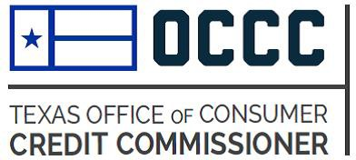
OCCC Debt Cancellation Agreement (DCA) Submission Form
Your First Name: | Your Last Name:
Your Company’s Name (include full name and any d/b/a):

Your Address: | Your Phone/Fax Number(s):  Phone:  Fax:
Your Email Address: | Date Form Is Being Submitted: (mm/dd/yyyy)
Type of DCA: Chapter 345 (motorcycle, RV, ATV, snowmobile, camper, boat, personal watercraft and personal watercraft trailer)
Chapter 348 (motor vehicle)
BOTH

Form Number (should uniquely identify the form submitted): | Date Form Was Last Revised: (mm/dd/yyyy)
- Required Nonrefundable Filing Fee: $250 for each submitted debt cancellation agreement
- Submission Process: Before submitting the agreement, we encourage you to read the OCCC's advisory bulletin, "Review of Debt Cancellation Agreements Requiring Insurance” posted on our website.
The submission process is now entirely online. Email a completed copy of this Submission Form and a text-searchable Abode Acrobat (PDF) “clean” version of document to DebtCancellationForms@occc.texas.gov. Request online payment in this email. We will send an online payment link to the sender’s address. For a limited time, we will continue to accept payment by check. In this case, mail this form and a check for $250 to:
Office of Consumer Credit Commissioner 2601 N. Lamar Blvd.
Austin, TX 78705
Submission is not complete until the filing fee and debt cancellation agreement are received by our agency.
C. Certificate of Compliance: Before sending the agreement to the OCCC, carefully review the agreement and check all boxes to acknowledge the following:
The agreement is a debt cancellation agreement that is intended to be used for motor vehicle retail installment transactions or consumer goods retail installment transactions under Chapter 354 of the Texas Finance Code.
The agreement includes insurance coverage as part of the buyer's responsibility to the holder.
The agreement includes all provisions required by Section 354.004 of the Texas Finance Code.
The agreement does not contain any inconsistent or misleading provisions.
Any exclusions in the agreement are fully disclosed in plain language.
Approved debt cancellation agreements are public information under Section 354.005(f) of the Texas Finance Code.
Signature:
Last Revised 12/15/22
Your Name:
Your Title:

