ALECS
How to Apply For a Pawn Employee License
Review applicable statutes and rules by visiting occc.texas.gov, and clicking on the link for pawnshops and pawn employees.
When finished with review, create ALECS account: https://alecs.occc.texas.gov/

- Create ALECS account
- Check your email and activate account
- Verify you don’t have a license
- Click on “Acquire New License” under “Submit Application”
- Enter basic information
- Enter 5 year residence history
- Enter 5 year occupation history
- Answer Questionnaire
- Upload documents as needed
- Select payment option (self pay or payment by employer)
- Pay
- Schedule fingerprint appointment

- Create ALECS account at: alecs.occc.texas.gov
- Enter information as prompted
- Click on submit
*The word business also means pawn employee.
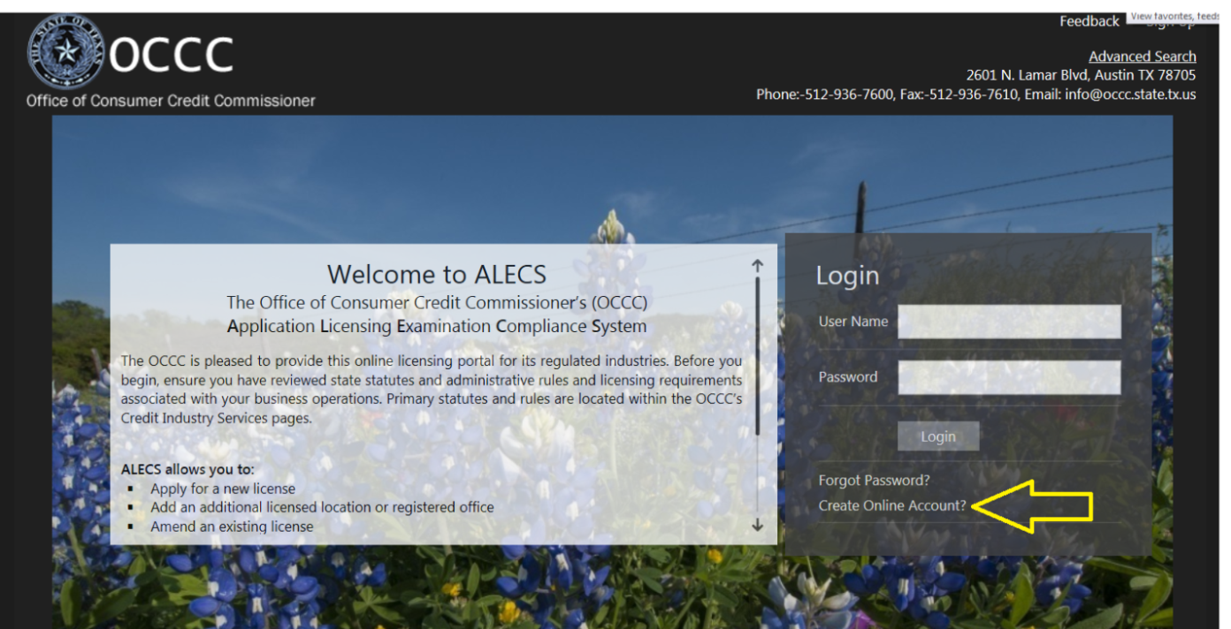
- Check your email account. (Email may be in spam folder.)
- Click link to activate your ALECS account
- Log in as prompted.

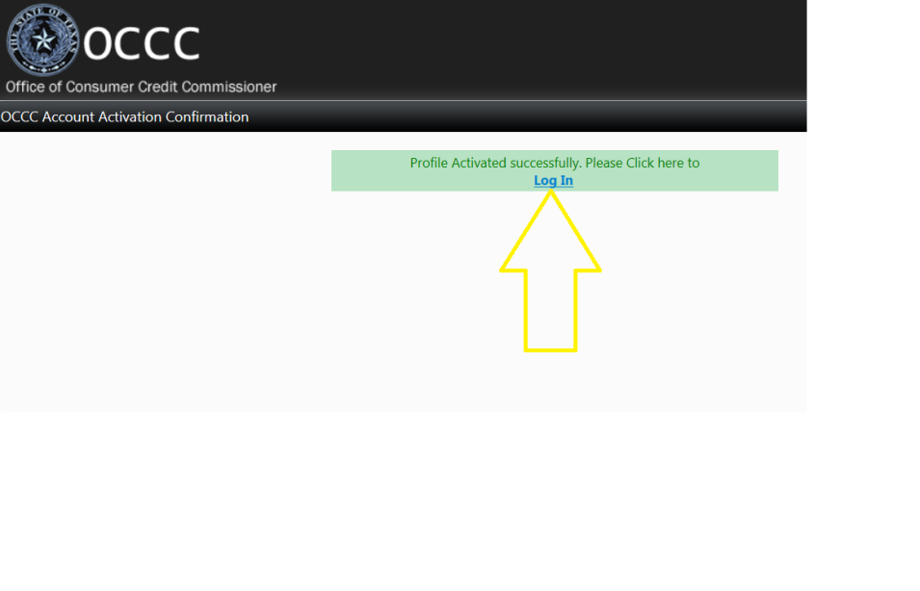
3. Verify you don’t have a license
- Select “pawn employee”, enter your social security number, click “Search”.
- If your social is not found, then click “skip”.
- If your social security number is found, select it to link, verify in your dashboard that link business request shows as “received”, and allow 3 business days before continuing to step 4
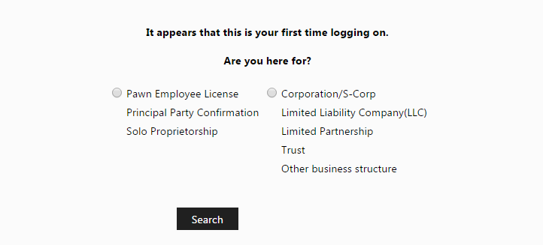

- Click on “Acquire New License” under “Submit Application”

- Enter basic information
  - Click “next”
*Click on the circled i for more information
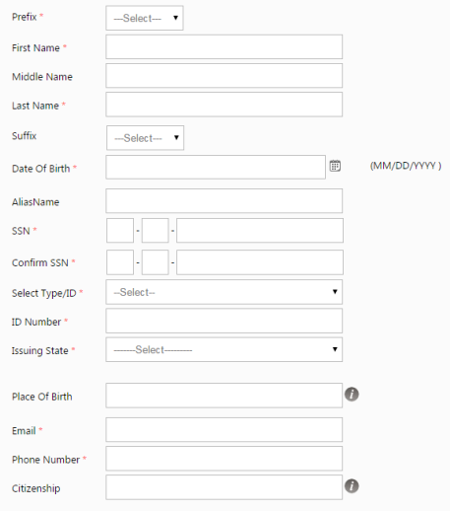
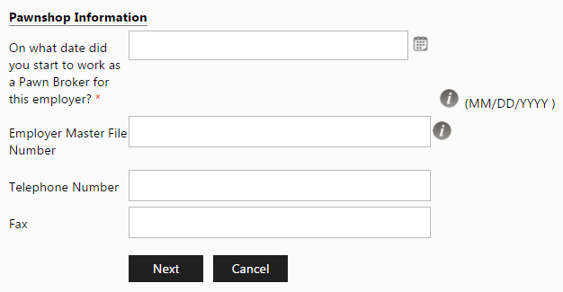

6. Enter 5 year residence history without gaps.
A. Click on “Add new record”
B. After each entry, click on “Insert”.
C. Add records until you have gone back five full years.
D. Only then, click “next”.
*If you click on “Next” before complete, go to the dashboard tab, click on the application line under “My new requests”, and click next until back to residential details.
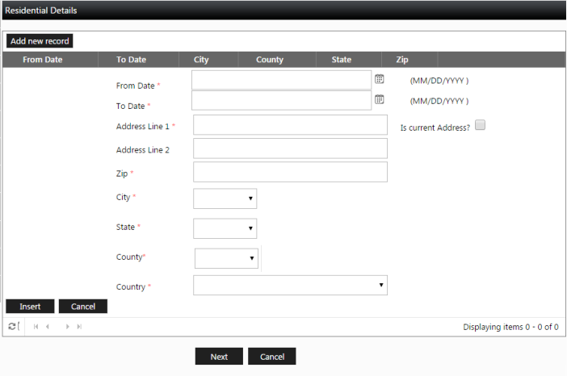

7.Enter 5 year occupation history without gaps.
A. Click on “Add new record”
B. After each entry, click on “Insert”.
C. Add records until you have gone back five full years.
D. Only then, click “next”.
*If you click on “Next” before complete, go to the dashboard tab, click on the application line under “My new requests”, and click next until back to employment details.
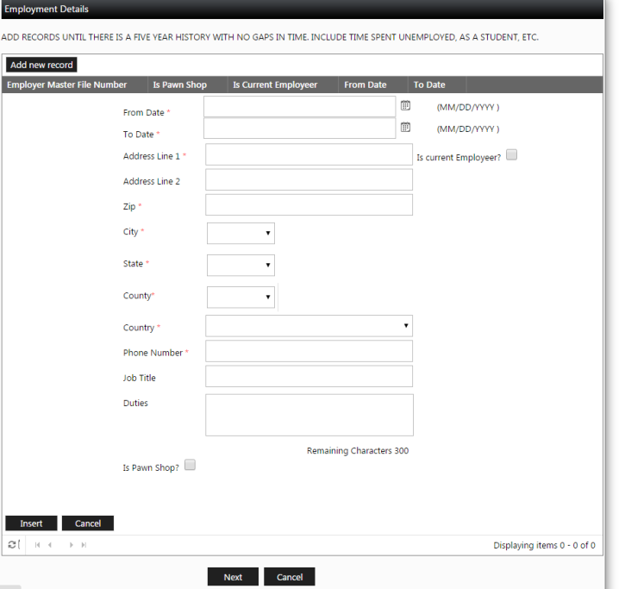

8. Answer Questionnaire
If you answer “No” to “Are you familiar with the Texas Pawnshop Act and all rules promulgated thereunder?” you will not be able to be licensed.
If you answer “Yes” to any other question, you will be required to upload a document explaining. This can be as simple as a word document that says “#6- I have credit card debt.” Or “#12-My maiden name was Rodriguez.”
IMPORTANT-If you say you were never arrested, please be sure that is true. Lying on your application may be considered grounds for denial.
Commonly unknown:
- Misdemeanors are arrests. ” Misdemeanor” is a level of arrest. It doesn’t mean an arrest didn’t happen.
- Arrests don’t expire. If you were arrested 30 years ago, you were arrested.
- If you were arrested with a different name, you were still arrested.
- Out of state arrests are arrests. The check will be nationwide.
- Not being convicted doesn’t mean you weren’t arrested. There is a separate question for convictions.
- Your record wasn’t expunged if a judge didn’t order it.

9. Upload documents if you answered “Yes” to any question other than “Are you familiar with the Texas Pawnshop Act and all rules promulgated thereunder?”
A. Upload as many documents as needed. Once complete, click next.

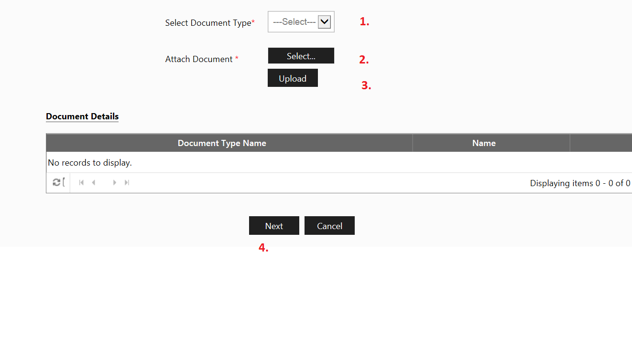

- Select payment option (self pay or payment by employer)
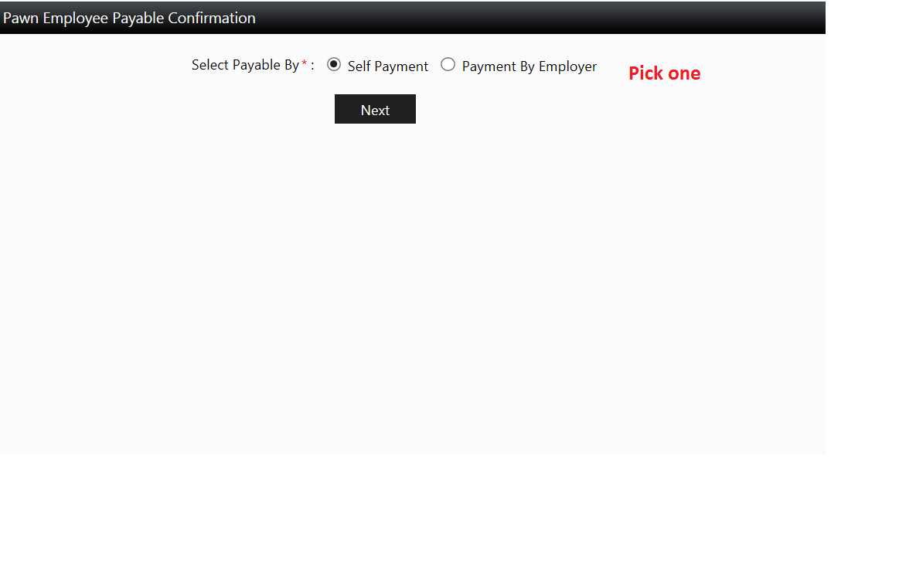

- Pay, if you have chosen self pay.
If you have selected payment by employer, your employer may log in to their account to pay for the application.
*Only after payment will the application be considered received by OCCC.

- Schedule fingerprint appointment using form at: http://occc.texas.gov/industry/fingerprints

- Check your email and notifications regularly.
- You may continue work as a pawnbroker until licensed or denied.

