How to Manage Your ALECS Profile

A guide to changing:
- Email
- Password
- Security Questions

Log into your account at: alecs.occc.texas.gov
- Click on “Manage Profile”.
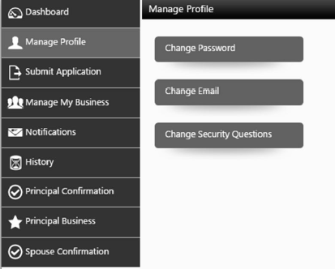
For email, see #4. For security questions, see #5.

- For a password change
- click on “Change Password”
- Enter the passwords as prompted on the screen
- Click “Update”.
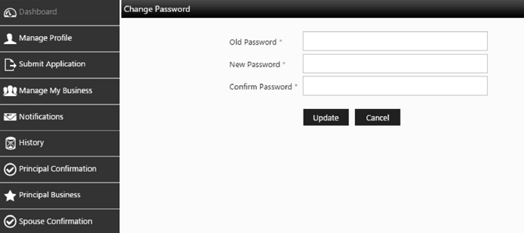

4. For an email change:
a. Click on “Manage Profile”
b. Click on “Change Email”.
c. Enter the emails as prompted and then click “Update”.
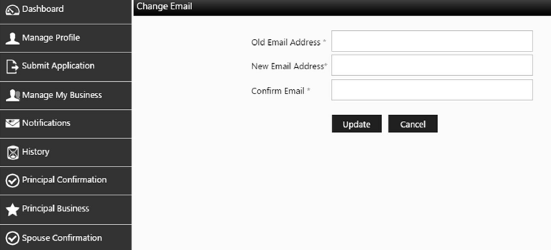
5. For security question changes:
a. Click on “Manage Profile”
b. Click on “Change Security Questions”.
c. Enter the new answers as prompted and then click “Update”.
