Search- Is Employee Licensed?

- Go to https://alecs.occc.texas.gov/
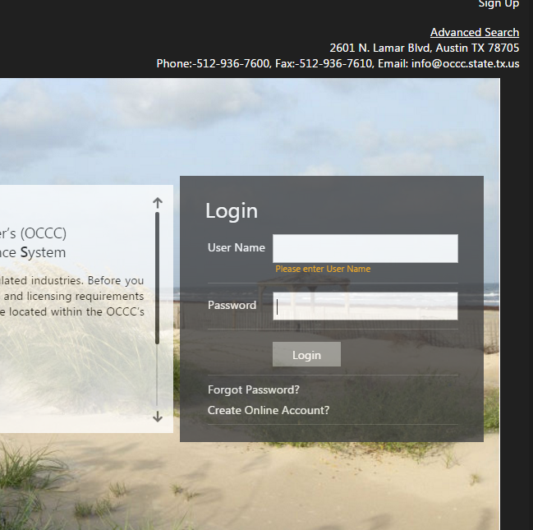

- Click on Advanced Search in in top right hand corner.


- Drop down to Pawn Employee as business type.


- Enter social security number

- Click “Search”


If status is Active or Inactive, employee is licensed.
For any other status, employee must apply.
